Documentation

Here Detail about APIs endpoint , first all steps that to help how project are created.

Here I describe steps how to complete this project:

Step-1:install all pakages like nodemon express mysql jsonwebtoken use npm install method

step-2: create index.js file where i write some important code to run my server

step-3: create mysql.js file where i write sql connection code and steup username and password and just very important things i write my code run and connect database first and then start server

step-4:write sql query for creating all table that are use in my code like cart,order,user,product,category and use foreign key for creating relations

step-5:created controller where i created all api method and export it and use JWT for authentications controller are cartController,orderController,productController,usersControllers

step-6:created routers for each controllers and manage in one index.js file all routers for handle easy and then index.js router connect(use) in main index.js server file

step-7: start my project use npm start and then calling api from postman

1-Api for register user :- <http://localhost:8090/api/user/register> Method:-POST

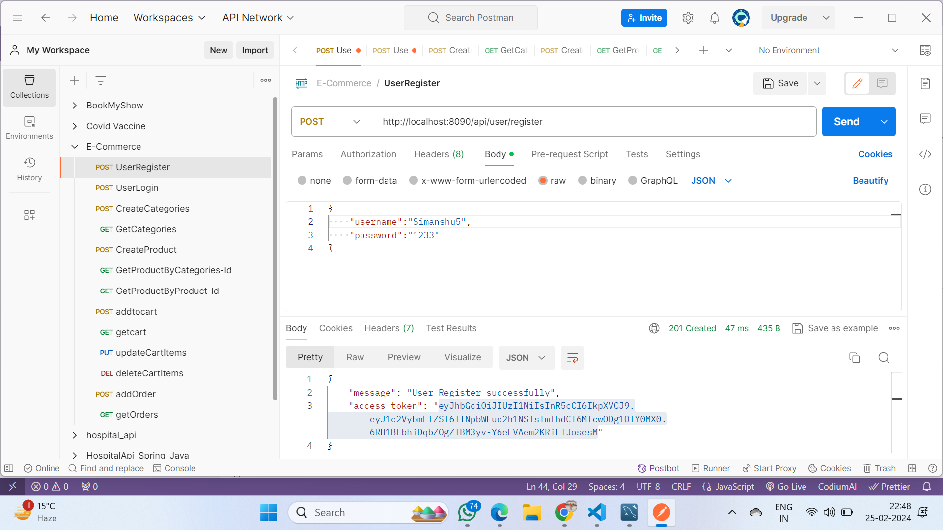

2- Api for login user:- <http://localhost:8090/api/user/login> Method:-POST

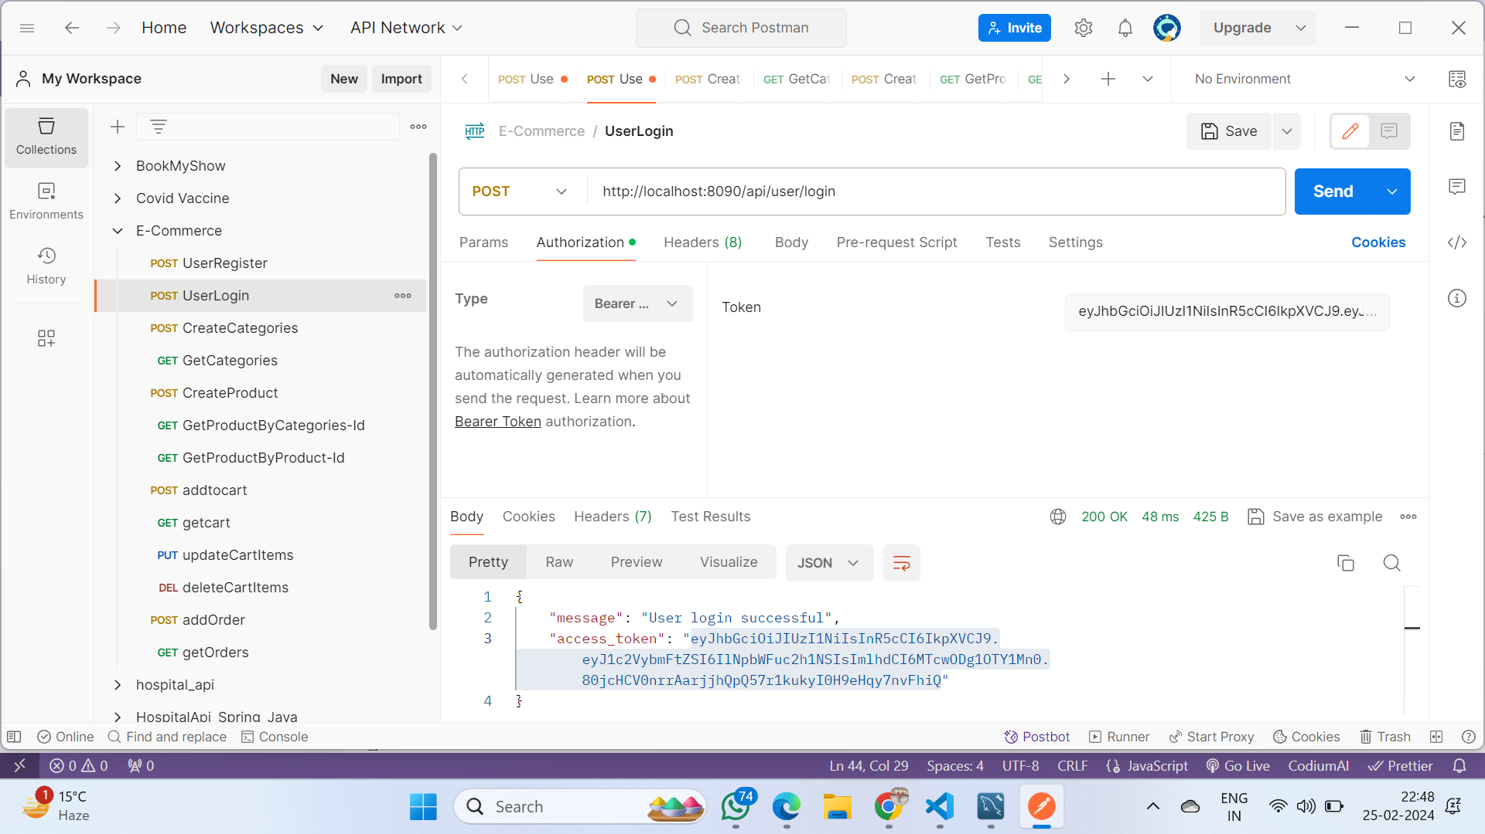

3- Api for Create categories:- <http://localhost:8090/api/product/categories> Method:-POST

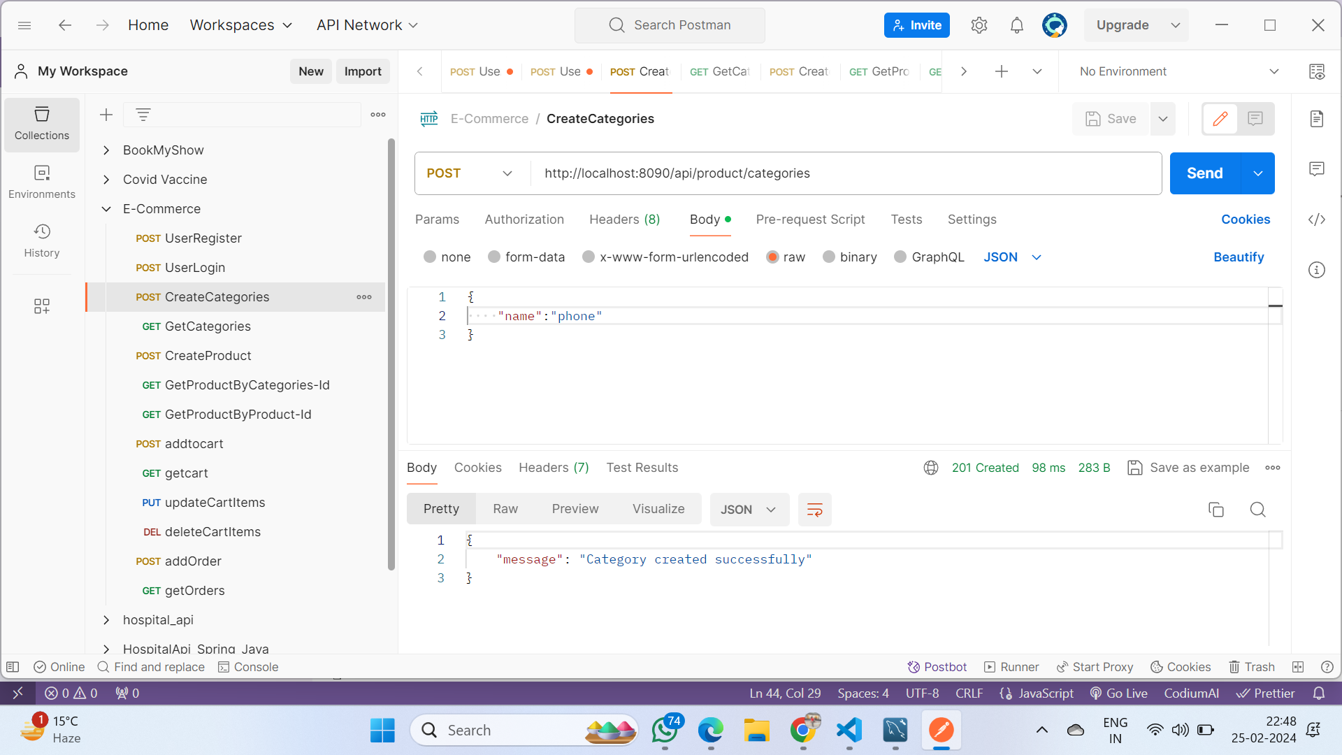

4-Api for get categories :- <http://localhost:8090/api/product/categories> Method:-GET

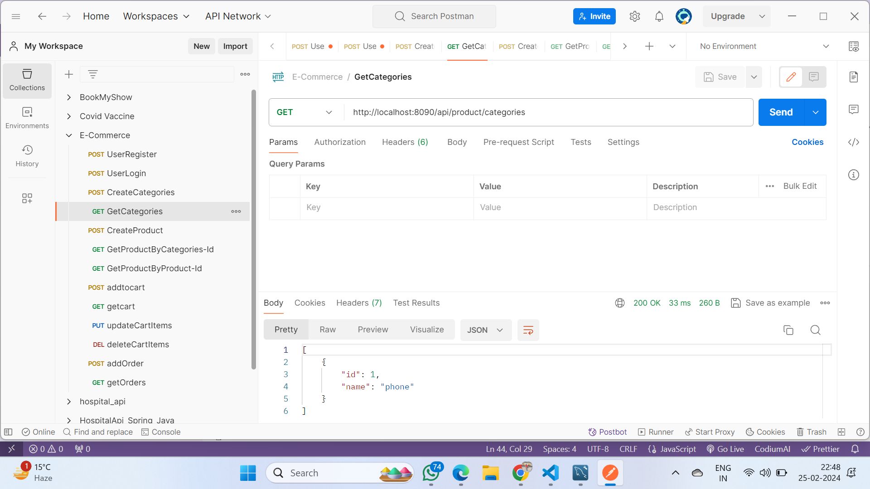

5-Api for create product :- <http://localhost:8090/api/product/products> Method:-POST

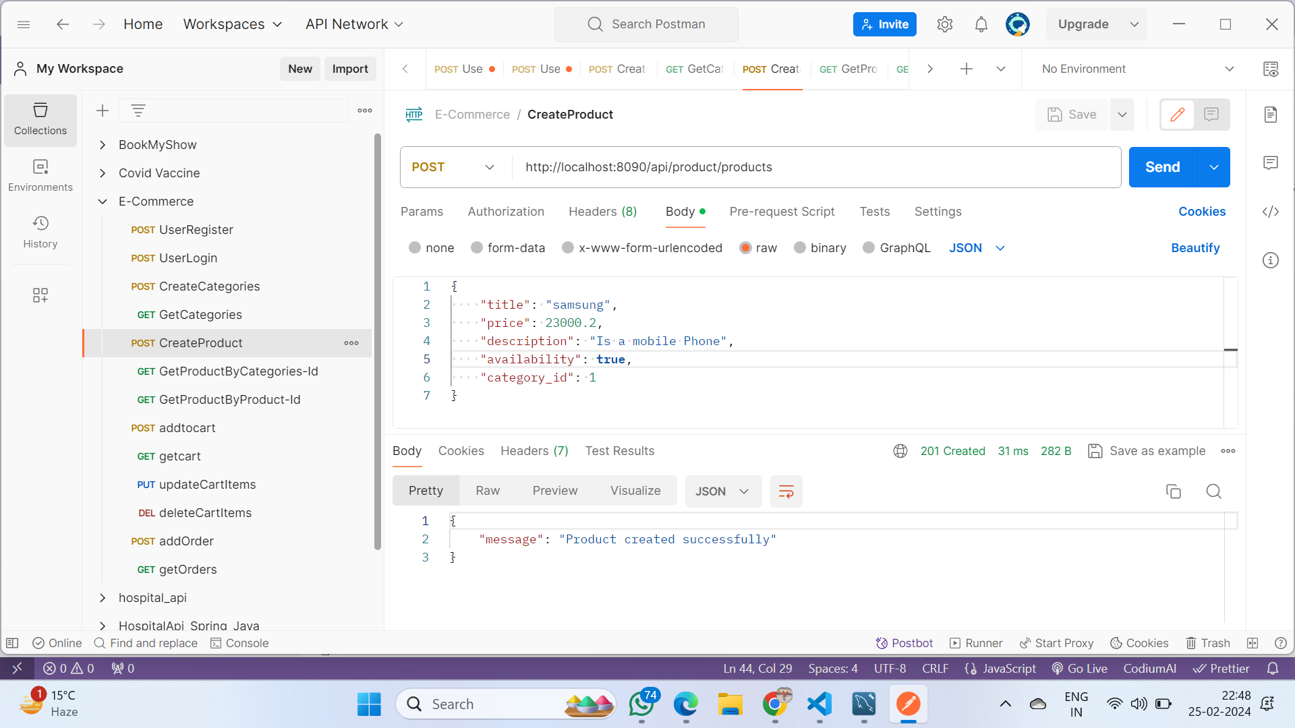

6-Api for get product by categories id :- <http://localhost:8090/api/product/products/:category_id> Method:-GET

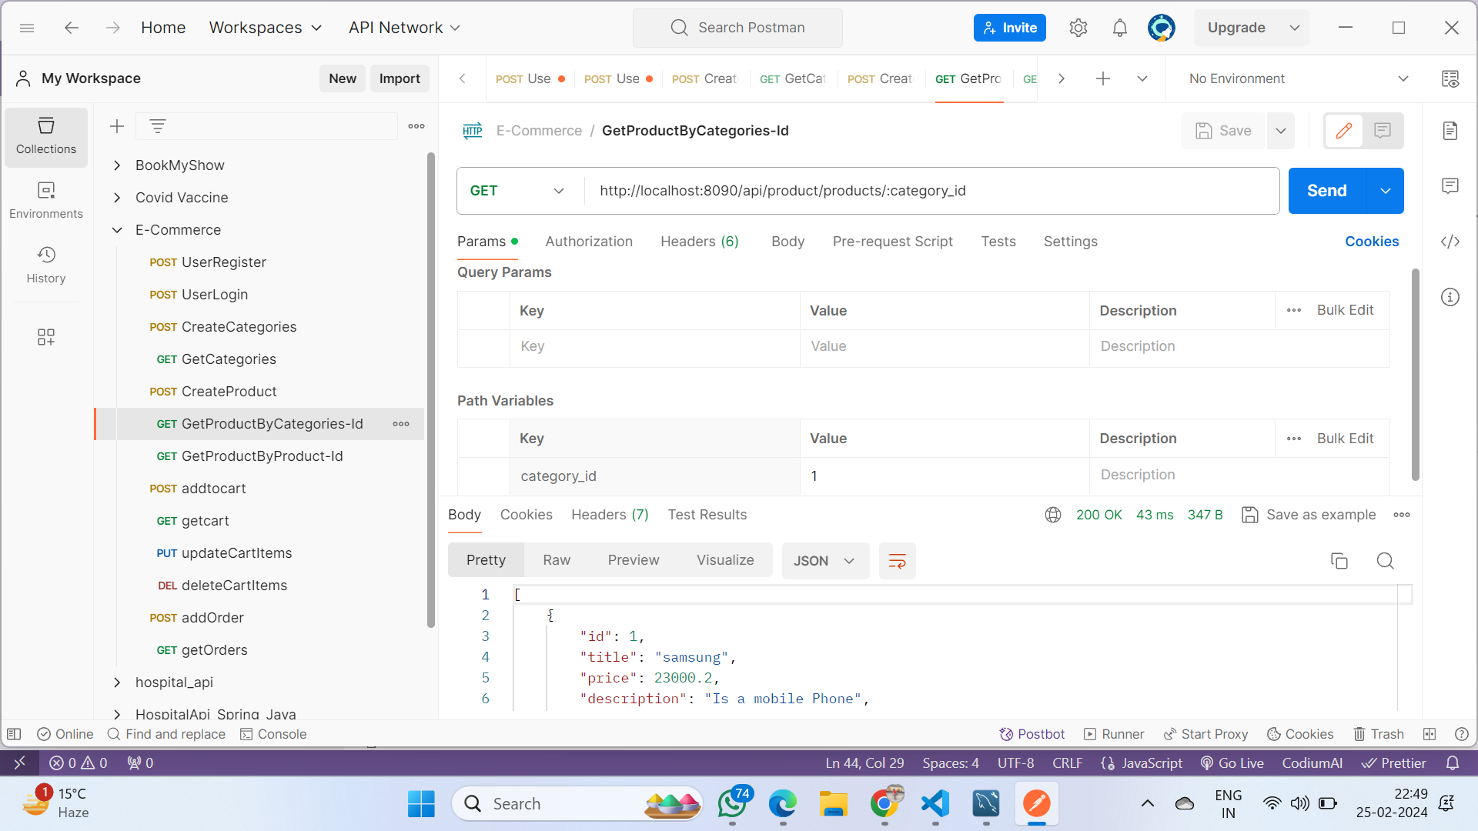

7-Api for get product by product id :- <http://localhost:8090/api/product/product/:product_id> Method:-GET

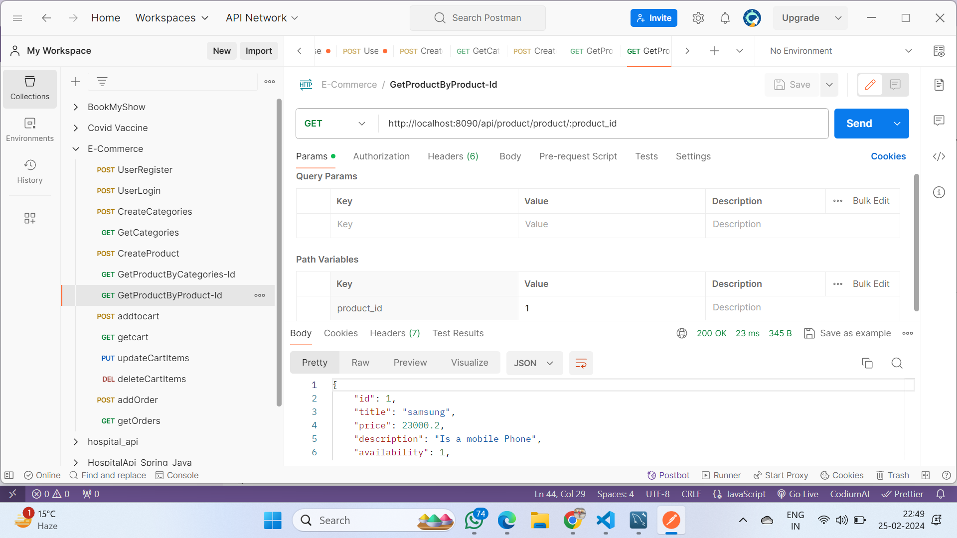

8- Api for add item to cart:- <http://localhost:8090/api/cart/cart> Method:-POST

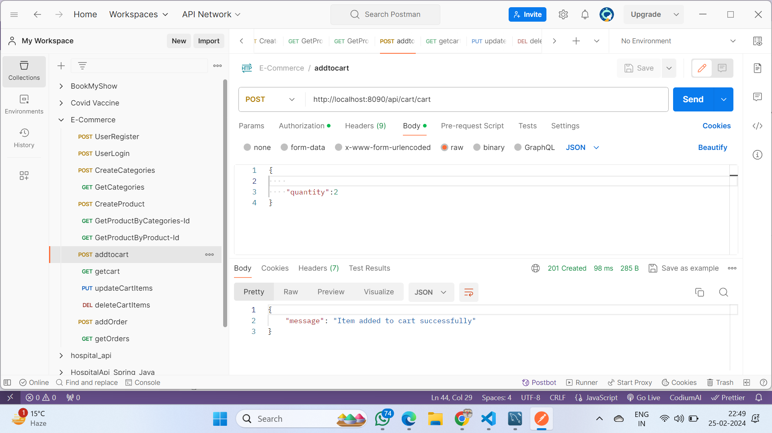

9-Api for get cart items :- <http://localhost:8090/api/cart/cart> Method:-GET

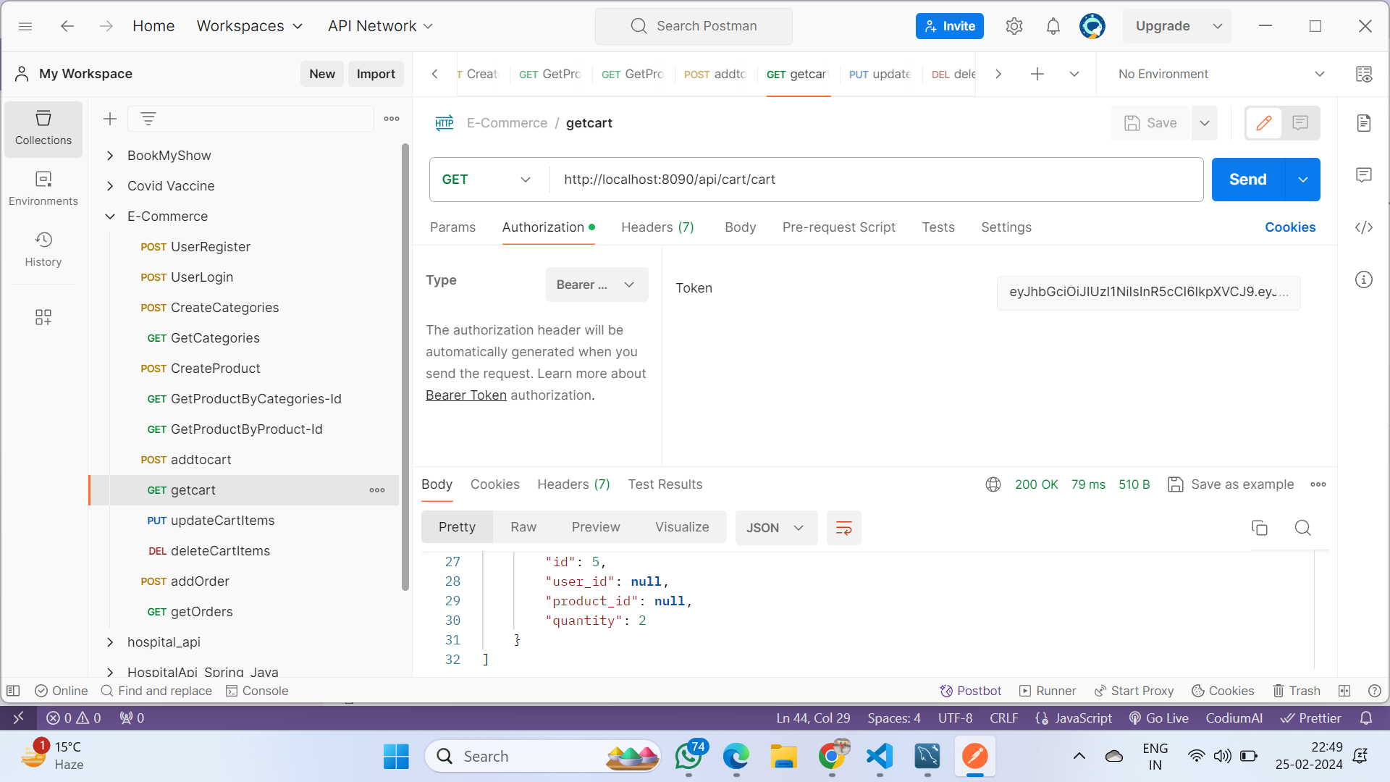

10- Api for update cart items :- <http://localhost:8090/api/cart/cart/:item_id> Method:-PUT

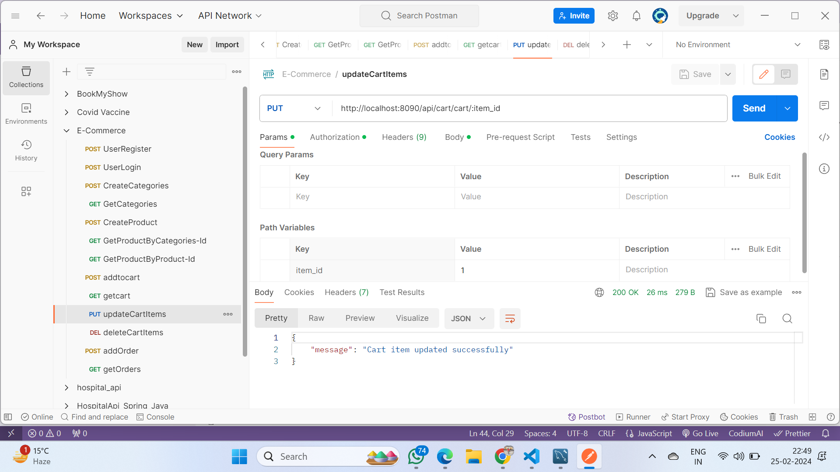

11-Api for delete cart items:- <http://localhost:8090/api/cart/cart/:item_id> Method:-DELETE

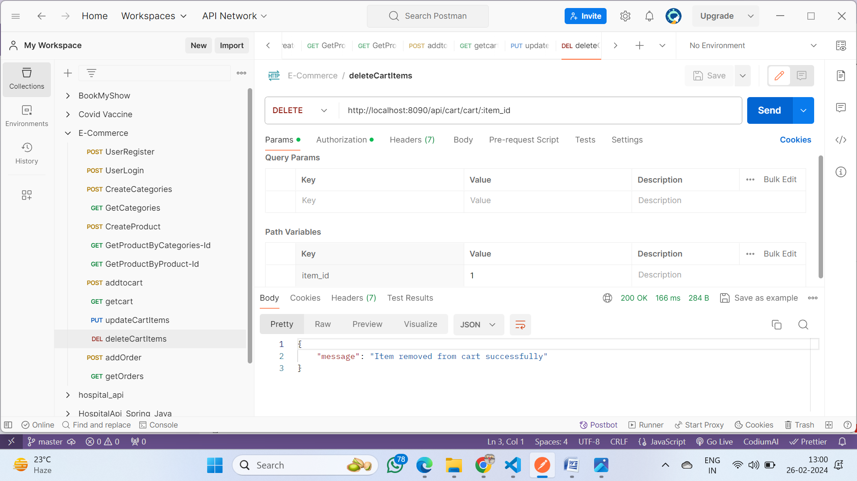

12- Api for Add order:- <http://localhost:8090/api/order/order> Method:-POST

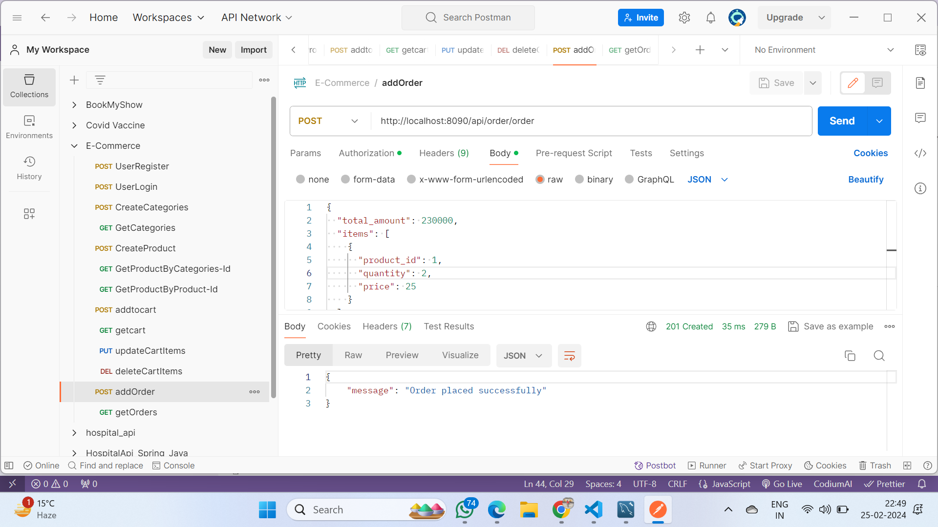

13- Api for get order:- <http://localhost:8090/api/order/orders> Method:-DELETE

